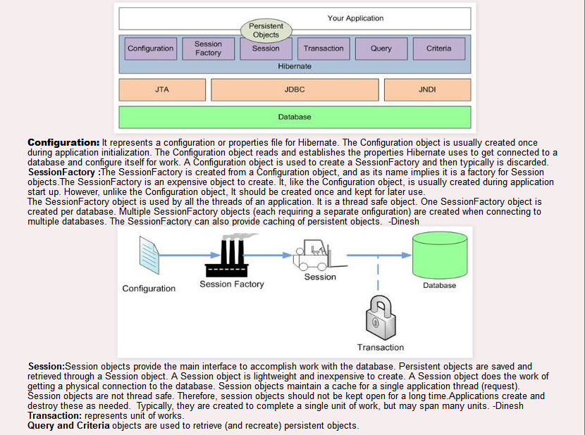

Note : SessionFactory is Thread Safe but Session is not thread safe.

Q :-The ORM tool internally uses the JDBC API and JNDI to interact with the database.

Q.Difference between session.save() , session.saveOrUpdate() and session.persist()
session.save() : Save does an insert and will fail if the primary key is already persistent
session.saveOrUpdate() : saveOrUpdate does a select first to determine if it needs to do an insert or an update. Insert data if primary key not exist otherwise update data.
session.persist() : Does the same like session.save(). But it has some difference like
- session.save() return Serializable object(prmary key) but session.persist() return void.
- Session.save() can be used inside or outside of Transaction Boundaries. But Persist() can work with in Transaction Boundaries.

For Example :
Employee e1 = new Employee();
e1.setAddress("Delhi");
e1.setName("Ravi Singh");
session.persist(e1);
session.evict(e1); // remove the object from session.
session.persist(e1);
tran.commit();
It will give an Exception………………………………...
Employee e1 = new Employee();
e1.setAddress("Delhi");
e1.setName("Ravi Singh");
session.save(e1);
session.evict(e1); // remove the object from session.
session.save(e1);
tran.commit();
It will run……………………………………………..

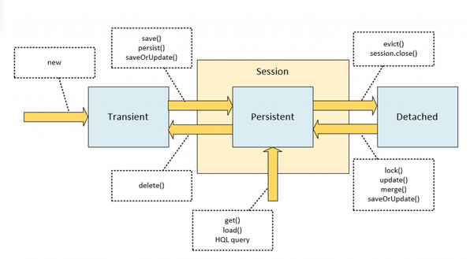

Q. Difference between session.saveOrUpdate() and session.merge()?

Use update() if you are sure that we are in the session so we can use the update before close session , and merge() if you want to merge your modifications at any time without consideration of the state of the session.
Employee emp1 = new Employee();
emp1.setEmpId(100);
emp1.setEmpName("Dinesh");
//create session
Session session1 = createNewHibernateSession();
session1.saveOrUpdate(emp1);
session1.close();
//emp1 object in detached state now
emp1.setEmpName("Dinesh Rajput");//Updated Name
//Create session again
Session session2 = createNewHibernateSession();
Employee emp2 =(Employee)session2.get(Employee.class, 100);
//emp2 object in persistent state with id 100
//below we try to make on detached object with id 100 to persistent state by using update method of hibernate

session2.update(emp1);//It occurs the exception NonUniqueObjectException because emp2 object is having employee with same empid as 100. In order //to avoid this exception we are using merge like given below instead of session.update(emp1);

session2.merge(emp1); //it merge the object state with emp2
session2.update(emp1); //Now it will work with exception

Q.What is Session.evict();
session.evict(obj) will remove the object instance from the session cache. Therefore if you are saving the object for the first time, you will have to explicitly commit via session.save(obj) before evicting the object from the cache.
Exam:
session.saveOrUpdate(theObject);
session.evict(theObject);

Q.What is the difference between hibernate and jdbc
There are so many
1) Hibernate is data base independent, your code will work for all ORACLE,MySQL ,SQLServer etc.
In case of JDBC query must be data base specific.
2) As Hibernate is set of Objects , you don?t need to learn SQL language.
You can treat TABLE as a Object . Only Java knowledge is need.
In case of JDBC you need to learn SQL.
3)You will get benefit of Cache. Hibernate support two level of cache. First level and 2nd level. So you can store your data into Cache for better performance.
In case of JDBC you need to implement your java cache .
4) Development fast in case of Hibernate because you don?t need to write queries

Q.What is the difference between hibernate and JPA.
JPA is just a specification, meaning there is no implementation. while Hibernate's JPA implementation. JPA is a specification for accessing, persisting and managing the data between Java objects and the relational database. As the definition says its API, it is only the specification. There is no implementation for the API. JPA specifies the set of rules and guidelines for developing the interfaces that follows standard. Straight to the point : JPA is just guidelines to implement the Object Relational Mapping (ORM) and there is no underlying code for the implementation.

Q. What is lazy fetching in Hibernate? With Example
Lazy fetching decides whether to load child objects while loading the Parent Object.
You need to do this setting respective hibernate mapping file of the parent class.
Lazy = true (means not to load child)
By default the lazy loading of the child objects is true.

Q. What is version checking in Hibernate ?
version checking used in hibernate when more then one thread trying to access same data.
For example :
User A edit the row of the TABLE for update ( In the User Interface changing data - This is user thinking time)
and in the same time User B edit the same record for update and click the update.
Then User A click the Update and update done. Chnage made by user B is gone.
In hibernate you can perevent slate object updatation using version checking.

Q. Difference between session.update() and session.lock() in Hibernate
Both of these methods and saveOrUpdate() method are intended for reattaching a detached object.
The session.lock() method simply reattaches the object to the session without checking or updating the database on the assumption that the database in sync with the detached object.
It is the best practice to use either session.update(..) or session.saveOrUpdate().
Use session.lock() only if you are absolutely sure that the
detached object is in sync with your detached object or if it does not matter because
you will be overwriting all the columns that would have changed later on within the same transaction

Q. Difference between list() and iterate() i9n Hibernate?
If instances are already be in the session or second-level cache iterate() will give better performance. If they are not already cached, iterate() will be slower
than list() and might require many database hits for a simple query

Q. Difference between session.load() and session.get()
Load() will throw an unrecoverable exception if there is no matching database row.
get() will return null if there is no matching database row.

Q. What is Hibernate proxy?
By default Hibernate creates a proxy for each of the class you map in mapping file. This class contain the code to invoke JDBC. This class is created by hibernate using CGLIB.
Proxies are created dynamically by subclassing your object at runtime. The subclass has all the methods of the parent, and when any of the methods are accessed, the proxy loads up the real object from the DB and calls the method for you.

Q. addScalar() method in hibernate
addScalar() method confim that maxWeight is always double type.
This way you don't need to check for it is double or not.
Example:
Double max = (Double) sess.createSQLQuery("select max(cat.weight) as maxWeight from cats cat")
.addScalar("maxWeight", Hibernate.DOUBLE);

Q. What are the Instance states in Hibernate?
transient
The instance is not, and has never been associated with any persistence context. It has no persistent identity (primary key value).
persistent
The instance is currently associated with a persistence context. It has a persistent identity (primary key value) and, perhaps, a corresponding row in the database. For a particular persistence context, Hibernate
guarantees that persistent identity is equivalent to Java identity (in-memory location of the object).
detached

Q . What is Cascade :
Cascade attribute is mandatory, when ever we apply relationship between objects. If we write cascade = “all” then changes at parent class object will be effected to child class object too, if we write cascade = “all” then all operations like insert, delete, update at parent object will be effected to child object also

Q. What are the benefits of detached objects?
Detached objects can be passed across layers all the way up to the presentation layer without having to use any DTOs (Data Transfer Objects). You can later on re-attach the detached objects to another session.

Q. What are the pros and cons of detached objects?
Pros:
When long transactions are required due to user think-time, it is the best practice to break the long transaction up into two or more transactions.
Cons
In general, working with detached objects is quite cumbersome, and better to not clutter up the session with them if possible. It is better to discard them and re-fetch them on subsequent requests.

Q. Explain hibernate object states? Explain hibernate objects life cycle?
Persistent Transient objects do not have association with the databases and session objects. They are simple objects and not persisted to the database. Once the last reference is lost, that means the object itself is lost. And of course , garbage collected. The commits and rollbacks will have no effects on these objects. They can become into persistent objects through the save method calls of Session object.
Detached objects and collections are instances of persistent objects that were associated with a session but currently not associated with a session. These objects can be freely used as Data Transfer Objects without having any impact on your database. Detached objects can be later on attached to another session by calling methods like session.update(), session.saveOrUpdate() etc. and become persistent objects.
Transient objects and collections are instances of persistent objects that were never associated with a session. These objects can be freely used as Data Transfer Objects without having any impact on your database. Transient objects become persistent objects when associated to a session by calling methods like session.save( ), session.persist( ) etc.

Q. How does Hibernate distinguish between transient (i.e. newly instantiated) and detached objects?
- Hibernate uses the "version" property, if there is one.
- If not uses the identifier value. No identifier value means a new object. This does work only for Hibernate managed surrogate keys. Does not work for natural keys and assigned (i.e. not managed by Hibernate) surrogate keys.
- Write your own strategy with Interceptor.isUnsaved( ).

Q. What are Collection types in Hibernate?

A collection is defined as a one-to-many reference. The simplest collection type in Hibernate is <bag>.This collection is a list of unordered objects and can contain duplicates. This is similar to java.util.List. The content of a collection is required for a SQL query.

Object Satate :-

Before Session In Session After Session
Transient
Persistent
Detached

1. Transient State:
A New instance of a persistent class which is not associated with a Session, has no representation in the database and no identifier value is considered transient by Hibernate:
view plainprint?
- UserDetail user = new UserDetail();
- user.setUserName("Dinesh Rajput");
- // user is in a transient state
2. Persistent State:
A persistent instance has a representation in the database , an identifier value and is associated with a Session. You can make a transient instance persistent by associating it with aSession:
view plainprint?
- Long id = (Long) session.save(user);
- // user is now in a persistent state

3. Detached State:
Now, if we close the Hibernate Session, the persistent instance will become a detachedinstance: it isn't attached to a Session anymore (but can still be modified and reattached to a new Session later though).
view plainprint?
- session.close();
- //user in detached state

HQL:-
Hibernate created a new language named Hibernate Query Language (HQL), the syntax is quite similar to database SQL language. The main difference between is HQL uses class name instead of table name, and property names instead of column name.
Hibernate uses the following ways to retrieve objects from the database:
- Hibernate Query Language (HQL)
- Query By Criteria (QBC) and Query BY Example (QBE) using Criteria API
- Native SQL queries

Why WE USE HQL?
Although it is possible to use native SQL queries directly with a Hibernate-based persistence layer, it is more efficient to use HQL instead. The reasons of choosing HQL over the other two methods are given below.
- HQL allows representing SQL queries in object-oriented terms—by using objects and properties of objects.
- Instead of returning plain data, HQL queries return the query result(s) in the form of object(s)/tuples of object(s) that are ready to be accessed, operated upon, and manipulated programmatically. This approach does away with the routine task of creating and populating objects from scratch with the "resultset" retrieved from database queried.
- HQL fully supports polymorphic queries. That is, along with the object to be returned as a query result, all child objects (objects of subclasses) of the given object shall be returned.
- HQL is easy to learn and implement, as its syntax and features are very similar to SQL.
- HQL contains many advance features such as pagination, fetch join with dynamic profiling, and so forth, as compared to SQL.

Cacheing in Hibernate: First Level and Second Level Cache :-

Database
First Level Cache
Session Object
Client
Second Level Cache

Optional
The first-level cache: The first level cache type is the session cache. The session cache caches object within the current session but this is not enough for long level i.e. session factory scope. Hibernate uses first-level cache by default and you have nothing to do to use first-level cache.
The second-level cache: Second-level cache always associates with the Session Factory object. It is useful if you have multiple session objects from a session factory.While running the transactions, in between it loads the objects at the Session Factory level, so that those objects will be available to the entire application, not bound to single user. Since the objects are already loaded in the cache, whenever an object is returned by the query, at that time no need to go for a database transaction. In this way the second level cache works. The 'second-level' cache exists as long as the session factory is alive. The second-level cache holds on to the 'data' for all properties and associations (and collections if requested) for individual entities that are marked to be cached.

There are four ways to use second level cache.
- read-only: caching will work for read only operation.
- nonstrict-read-write: caching will work for read and write but one at a time.
- read-write: caching will work for read and write, can be used simultaneously.
- transactional: caching will work for transaction.
Points :
• Whenever hibernate session try to load an entity, the very first place it look for cached copy of entity in first level cache (associated with particular hibernate session).
• If cached copy of entity is present in first level cache, it is returned as result of load method.
• If there is no cached entity in first level cache, then second level cache is looked up for cached entity.
• If second level cache has cached entity, it is returned as result of load method. But, before returning the entity, it is stored in first level cache also so that next invocation to load method for entity will return the entity from first level cache itself, and there will not be need to go to second level cache again.
• If entity is not found in first level cache and second level cache also, then database query is executed and entity is stored in both cache levels, before returning as response of load() method.

Cache Strategy using with Annotation as some changes made to the Model class also.
- @Cacheable
- @Cache(usage = CacheConcurrencyStrategy.READ_ONLY)
- @Entity
- @Table(name="STUDENT")
- public class Student implements Serializable
- {
For Enabling the second level of cache we have to made following change to hibernate configuration file.
- <!-- Enable the second-level cache -->
- <property name="cache.use_second_level_cache">true</property>
- <property name="cache.provider_class">org.hibernate.cache.EhCacheProvider</property>

Named Queries in Hibernate:
Named Query is very useful concept in hibernate. The hibernate named query is way to use any query by some meaningful name. It lets you separate queries from coding section of the application to the mapping xml file(.hbm files). And if we use Annotation than we have to write in class file exam:-
- @NamedQueries({
- @NamedQuery(
- name = "findStudentByRollNumber",
- query = "from Student student where student.rollNumber = :rollNumber"
- )
- })
- @Entity
- @Table(name = "STUDENT")
- public class Student implements java.io.Serializable {

Diff Between NamedQueries And NamedQuery :-
@NameQueries annotation is used to define the multiple named queries.
@NameQuery annotation is used to define the single named query.

Q- : Interfaces in Hibernate
- Session Interface
- SessionFactory Interface
- Configuration Interface
- Transaction Interface
- Query and Criteria Interface

Q- : What are the benefits of using Hibernate template?
The Spring framework provides HibernateTemplate class, so you don't need to follow so many steps like create Configuration, BuildSessionFactory, Session, beginning and committing transaction,ExceptionHandling etc.
Ex:
- Employee e1=new Employee(111,"arun",40000);
- hibernateTemplate.save(e1);
.

Q:- What are the two types of collections in hibernate?
a.Sorted Collection
b. Order Collection

Q- What’s the usage of callback interfaces in hibernate?
Callback interfaces of hibernate are useful in receiving event notifications from objects. For example, when an object is loaded or deleted, an event is generated and notification is sent using callback interfaces.

Q- :What’s transaction management in hibernate? How it works?
Transaction management is the process of managing a set of statements or commands. In hibernate; transaction management is done by transaction interface as shown in below code:
?
1  2  3  4  5  6  7  8  9  10  11  12 | Session s = null;  Transaction tr = null;  try {  s = sessionFactory.openSession();  tr = s.beginTransaction();  doTheAction(s);  tr.commit();  } catch (RuntimeException exc) {  tr.rollback();  } finally {  s.close();  }
Q-: What are different ways to disable hibernate second level cache?
Ans Hibernate second level cache can be disabled using any of the following ways:
a. By setting use_second_level_cache as false.
b. By using CACHEMODE.IGNORE
c. Using cache provider as org.hibernate.cache.NoCacheProvider

What different fetching strategies are of hibernate?
Following fetching strategies are available in hibernate:
1. Join Fetching
2. Batch Fetching
3. Select Fetching
4. Sub-select Fetching

What’s the use of version property in hibernate?
Version property is used in hibernate to know whether an object is in transient state or in detached state.

What’s the use of session.lock() in hibernate?
session.lock() method of session class is used to reattach an object which has been detached earlier.

How to get No. Of Result from database
Query query = (Query) session.createQuery(sql);
((org.hibernate.Query) query).setFirstResult(fromRecords); // in fromRecord we have to pass
no of records which u want to display

return ((org.hibernate.Query) query).list();

Value Type & Entity Type Object or @Embedding type Object

We’ll learn the difference between Entity type objects and Value type objects. We’ll use the @Embeddable annotations to embed a value type object into our Entity class.

Entity type objects : - has its own database identity Like:-

@Entity
@Table(name="USER_TABLE")
public class UserDetails{
@Id
@GeneratedValue
@Column(name="USER_ID", type="INTEGER")
private long userId;
@Column(name="USER_NAME", type="String")
private String userName;
@Column(name=USER_ADDRESS, type="String")
private String address;
@Column(name="USER_PHONE", type="INTEGER")
}

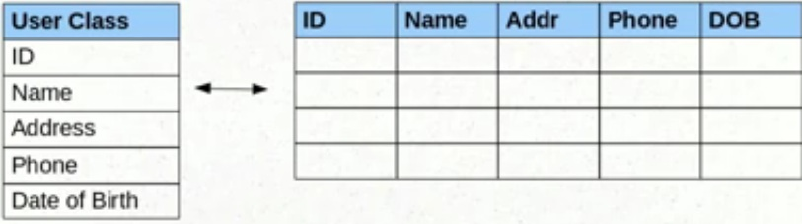
Here User class Field have database related Entity.

Object of Value Type :- belongs to an entity, and its persistent state is embedded in the table row of the owning entity. Value types don't have identifiers or identifier properties. Like :-
@Entity
@Table(name="USER_TABLE")
public class UserDetails{
@Id
@GeneratedValue
@Column(name="USER_ID", type="INTEGER")
private long userId;
@Column(name="USER_NAME", type="String")
private String userName;
@Column(name=USER_ADDRESS, type="??????") //What should be type for database
private Address address;
@Column(name="USER_PHONE", type="INTEGER")
private long phone;
@Column(name="DOB", type="TIMESTAMP")
private Date dob;
}
As we can see above private Address address
Address is the Address class which is used here as a Property . here USER CLASS have a field Address type of the Value type object means in the database there are no meaning of Address type object.
Address type object have the four other fields like.
1. Street
2. City
3. State
4. Pin code
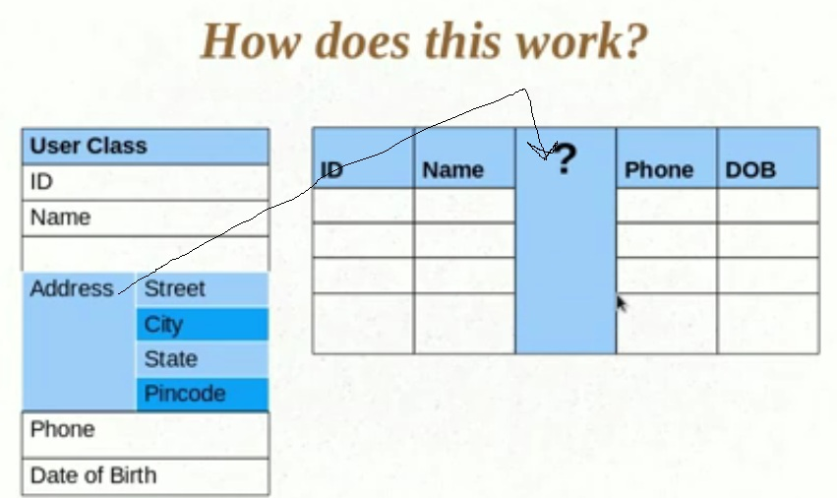
Proxy Object
An object proxy is just a way to avoid retrieving an object until you need it. If you want retrieve user object from the database, so what field value are retrieved from the database and which field are initialized. Suppose one user XYZ has the 100 addresses in the database and we want to retrieved the name of this user from database. For that we retrieve the user object, now question is this what about the field listOfAddress field, Is it also have the value? if you say yes so what about cost of memory ? if you say no so how to retrieve the value associated with that field the address table in the database on demand.
In Hibernate 2 does not proxy objects by default. In Hibernate 3, when we fetching the user object from the database actually its retrieved the proxy object of the user class means only first level of the fields are initializing with the associated values from the database. Field listOfAddresses does not have the value. If you want the list address you should call the following method you will get the listOfAddresses.
user.getListOfAddress(); --->> this return the list of the address associated with that particular user which name is XYZ this is the default behavior of the Hibernate 3.
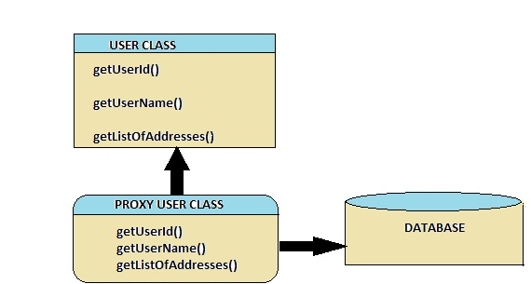

Fetching Strategies:-
If we are talking of Fatching Strategies it means we are talking more then 1 entity , The fetch type essentially decides whether or not to load all of the relationships of a particular object/table are load or not , there are two types of the fetching strategies in the hibernate.
1. Lazy Fetch type
2. Eager Fetch type
LAZY = fetch when needed(demand)
EAGER = fetch immediately
- Lazy Fetch Type: This the default fetch type of the hibernate 3.. In that case original object does not return. in case of Lazy always two query is execute instead of single query . and it work with in session if we close the session before execute the getListAddress() , it will give an exception. Like:-

session.close(); // close the session before calling collection getter System.out.println(user.getLisOfAddresses().size());

Now when you load a User from the database, JPA loads its id, name, and address fields for you. But you have two options for users: to load it together with the rest of the fields (i.e. eagerly) or to load it on-demand (i.e. lazily) when you call the user's getListOfAddresses() method.

- Eager Fetch type :- In that case original object is return. It will always execute a single query instead of two query. And we can execute it after close the session.
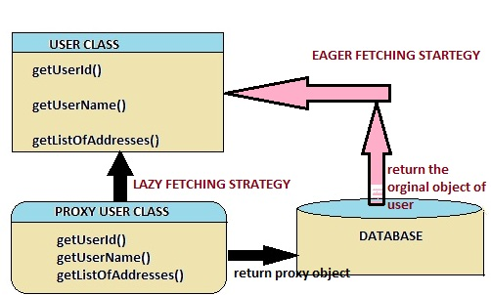

Q:- What is Inverse ?
Ans : The “inverse” keyword is always declared in one-to-many and many-to-many relationship (many-to-one doesn’t has inverse keyword), It defines which side is responsible to take care the relationship. In Hibernate, only the relationship owner should maintain the relationship, and the “inverse” keyword is created to defines which side is the owner to maintain the relationship. The inverse=”true” means this is the relationship owner, whereas inverse=”false” (default) means it’s not.
Example:
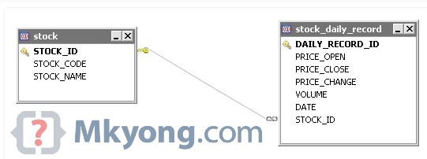
It’s one to many relationship so if we set Inverse=true in “stock_daily_record” table it means stock_daily_record is the relationship owner and Stock table will not update the relationship.
If inverse=”false” (default), it means “stock” is the relationship owner, and Stock will UPDATE the relationship.

Q:- Inheritance In Hibernate : -
Ans :- Three types of Inheritance
  - InheritanceType.JOINED
  - InheritanceType. SINGLE_TABLE
  - InheritanceType. TABLE_PER_CLASS
  - InheritanceType. TABLE_PER_CONCREATE_CLASS

JOINED:
The nature of InheritanceType.JOINED is that the properties of super entity will be inherited by derived entity. And in the database the columns which super table contains will not be available in sub table.
Example we have parent entiry Employee and two sub entity paramenet_Emp and Temp_Emp , then in data base 3 tables are created but the column of employee table will not show in derived tables.
SINGLE_TABLE:
InheritanceType.SINGLE_TABLE works by single table. There will be one super entity and one derived entity and when we insert data for any entity, data will be inserted into single table.
TABLE_PER_CLASS :
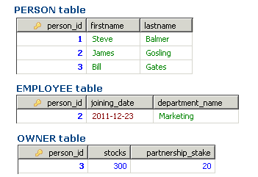
TABLE_PER_CONCREATE_CLASS : there is a repetation field of parent class into sub class.
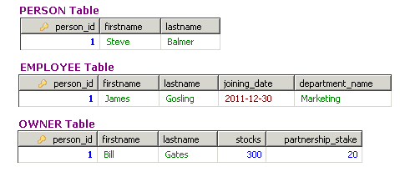

Locking in Hibernate :-
Locking refers to taken an action to prevent data in a relational database from changing between the time it is read and the time that it is used.
There are two types of locking :-
1.Optimistic:- Optimistic locking assumes that multiple transactions can complete without affecting each other.
In optimistic locking, the object is not locked when it is accessed for the first time in the transaction. Instead, of we used to Version Number for saved. When other transactions that are accessing the same object try to modify the state of the object, the present state and the saved state are compared. If the states differ, then it's a clear indication of a conflicting update and the transaction will be rolled back.
Ex,:
@Version
public long getVersion()
{
return version;
}

2. pessimistic :- In pessimistic locking, the object is locked when it is initially accessed for the first time in a given transaction. The lock then is released only when the transaction completes; the object is not accessible for any other transactions during the transaction.

Q:-Diff Between Session.Commit and Session.Flush.
Ans :-

Q :- How to make detached object persistent in hibernate?
Ans:- Detached can be persisted using Session.update() or Session.merge() in hibernate.

Annotation in Hibernate : -
@JoinColumn :- it is used for foreign key.
@PrimaryKeyJoinColumn : for associated entities sharing the same primary key.
@JoinTable : a join table is created a new table to make the one-to-many association between the two tables.

Q :- Diff Between EntityManagerFactory and SessionFactory?
If you are using the JPA’s standard specification implementation (Read : Introduction to JPA), then you would use EntityManagerFactory for opening the session. But, if you are using the hibernate implementation, you have hibernate specific SessionFactory for managing the sessions. Here there is lot of confusion between developers like which one is the best approach. Here, there is two opinions are popular:
- EntityManagerFactory is the standard implementation, it is the same across all the implementations. If we migrate our ORM for any other provider, there will not be any change in the approach for handling the transaction. In contrast, if you use hibernate’s session factory, it is tied to hibernate APIs and ca not migrate to new vendor easily.
- One dis-advantage of using the standard implementation is that, it is not providing the advanced features. There is not much control provided in the EntityManager APIs. Whereas, hibernate’s SessionFactory has lot of advanced features which can not done in JPA. One such thing is retrieving the ID generator without closing the transaction, batch insert, etc.

Difference Between executeQuery() Vs executeUpdate() Vs execute() In JDBC.
executeQuery(), executeUpdate() and execute() are the methods of java.sql.Statement interface of JDBC API which are used to execute the SQL statements.
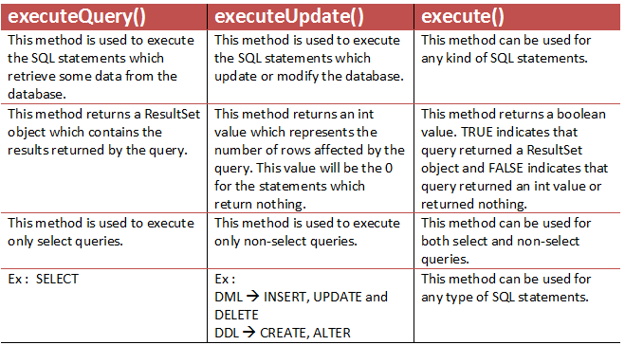

One To Many Relationship in Hibernate Example : - Hibernate one to many mapping is made between two entities where first entity can have relation with multiple second entity instances but second can be associated with only one instance of first entity. Its 1 to N relationship.
For example, in any company an employee can register multiple bank accounts but one bank account will be associated with one and only one employee .
we can resolve this problem in two ways
- One is to have a foreign key column in account table i.e. EMPLOYEE_ID.This column will refer to primary key of Employee table. This way no two accounts can be associated with multiple employees
- Second approach is to have a common join table lets say EMPLOYEE_ACCOUNT. This table will have two column i.e. EMP_ID which will be foreign key referring to primary key in EMPLOYEE table and similarly ACCOUNT_ID which will be foreign key referring to primary key of ACCOUNT table.
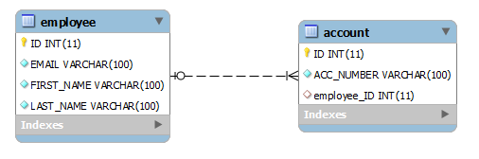
@Entity
@Table(name = "Employee”)
public class EmployeeEntity implements Serializable
{

private static final long serialVersionUID = -1798070786993154676L;

@Id
@GeneratedValue(strategy = GenerationType.IDENTITY)
@Column(name = "ID", unique = true, nullable = false)
private Integer employeeId;

@Column(name = "EMAIL", unique = true, nullable = false, length = 100)
private String email;

@Column(name = "FIRST_NAME", unique = false, nullable = false, length = 100)
private String firstName;

@Column(name = "LAST_NAME", unique = false, nullable = false, length = 100)
private String lastName;

@OneToMany(cascade=CascadeType.ALL)
@JoinColumn(name="EMPLOYEE_ID")
private Set<AccountEntity> accounts;

}

@Entity
@Table(name = "Account”)
public class AccountEntity implements Serializable
{
private static final long serialVersionUID = -6790693372846798580L;

@Id
@GeneratedValue(strategy = GenerationType.IDENTITY)
@Column(name = "ID", unique = true, nullable = false)
private Integer accountId;

@Column(name = "ACC_NUMBER", unique = true, nullable = false, length = 100)
private String accountNumber;

@ManyToOne
private EmployeeEntity employee;

}

- Using Join Table :
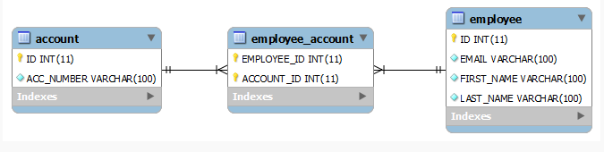
This approach uses a join table to store the associations between account and employee entities. @JoinTable annotation has been used to make this association.
public class EmployeeEntity implements Serializable
{
private static final long serialVersionUID = -1798070786993154676L;

@Id
@GeneratedValue(strategy = GenerationType.IDENTITY)
@Column(name = "ID", unique = true, nullable = false)
private Integer employeeId;

@Column(name = "EMAIL", unique = true, nullable = false, length = 100)
private String email;

@Column(name = "FIRST_NAME", unique = false, nullable = false, length = 100)
private String firstName;

@Column(name = "LAST_NAME", unique = false, nullable = false, length = 100)
private String lastName;

@OneToMany(cascade=CascadeType.ALL)
@JoinTable(name="EMPLOYEE_ACCOUNT", joinColumns={@JoinColumn(name="EMPLOYEE_ID"
, inverseJoinColumns={@JoinColumn(name="ACCOUNT_ID", referencedColumnName="ID")})
private Set<AccountEntity> accounts;

//Getters and setters
}

public class AccountEntity implements Serializable
{

private static final long serialVersionUID = -6790693372846798580L;

@Id
@GeneratedValue(strategy = GenerationType.IDENTITY)
@Column(name = "ID", unique = true, nullable = false)
private Integer accountId;

@Column(name = "ACC_NUMBER", unique = true, nullable = false, length = 100)
private String accountNumber;

//Getters and setters
}

Many to Many RelationShip : -
According to the relationship a student can enroll in any number of courses and the course can have any number of students.
To create this relationship you need to have a STUDENT, COURSE and STUDENT_COURSE table. The relational model is shown below.

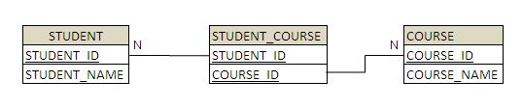
@Entity
@Table(name = "STUDENTS")
public class Student {
private long id;
private String name;

private Set<User> users = new HashSet<User>();

public Student (String name) {
this.name = name;
}

public void addUser(User user) {
this.users.add(user);
}

@Id
@GeneratedValue
@Column(name = "Student_ID")
public long getId() {
return id;
}

@ManyToMany(cascade = CascadeType.ALL)
@JoinTable(
name = "STUDENT_COURSE",
joinColumns = @JoinColumn(name = " Student_ID "),
inverseJoinColumns = @JoinColumn(name = "Course_ID")
)
public Set<User> getUsers() {
return users;
}

// other getters and setters...
}

@Embeddable and @Embedded annotation in hibernate :
One entity can be embedded in another entity. The attributes of an entity can be common attributes or we can change the name attribute of parent entity of more than one entity.so in that case we make parent class as a @Embeddadble

